**SERVICE SCHEDULE for August 23, 2020**

**Announcements for the Week** Cliff Davis

**Morning Service Evening Service**

**Prayer-** Cliff Davis **Prayer-** Cliff Davis

**Song Leader-** Connor LaChappelle **Song Leader-** Bill McIlvain

**-- Comments –** Buck Phillips **Comments –** Andy Fuller

-- **Assisting –** Brandon Esque **Communion –** Darryl Griffing

**-- Assisting –** Joshua Boone

**-- Assisting –** Ron Bailey

**-- Assisting –** Eli Hickey

**-- Scripture –** Josiah Phillips **Scripture –** Jared Davis

**Closing Prayer-** Phillip Dorn **Closing Prayer-** Lucian Griffing

**Wednesday Night – August 26, 2020**

**First Prayer–** Connor LaChappelle

**Song Leader –** Brandon Esque

**Invitation –** Buck Phillips

**Closing Prayer –** Cliff Davis

**August 23 Evening Service** – Buck Phillips

**Upcoming Assignments**

|  |  |  |
| --- | --- | --- |
| **August** | **Communion** | **Cleaning** |
| **23** | McIlvain | Take the time to police your area before you go. |
| **30** | Land | Cheerios and other cereals can draw ants. |

**Take Note**

**The Bible Classes have been a vital part of our local work here. Our appreciation goes to the teachers who selflessly devote to their students.**

**Work has commenced on the stage area. A special Thank You goes to the efforts of the men who are working on this project. Lord willing, we will continue the work next Saturday.**

[**www.covingtonchurchofchrist.com**](http://www.covingtonchurchofchrist.com)

**Live connection starting 9AM. CALL (678) 701-5124 Enter PIN: 1234**



***Schedule of Services***

**Sunday: 9 a.m., 10 a.m. & 5 p.m. Wednesday: 7:00 p.m.**

**Wi-Fi Password: church1234**

**This bulletin is published weekly. Edited by Bill McIlvain.**

**Send any articles for the bulletin to** [**Preacher@covingtonchurchofchrist.com**](mailto:Preacher@covingtonchurchofchrist.com)

**Visit us on the web: www.covingtonchurchofchrist.com**



**9441 Bypass, P.O. Box 768, Covington, GA 30015 --- [770] 787-1119**

**Elders: Jason LaChappelle, Bill McIlvain**

**Deacons: Cliff Davin, Darryl Griffing, Buck Phillips**

**August 23, 2020**

***The Company of Apostles***

1. What hard working companion of Paul was called an apostle?

2. Who preached at Pentecost?

3. Who was banished to the island of Patmos?

4. By what other name was Matthew known?



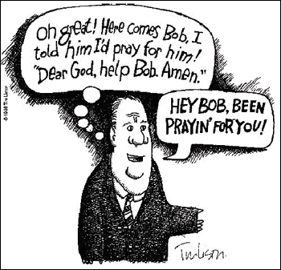***Prayer Requests:***

Maybe you have been in this situation. Sometimes someone may come to you with a very heavy heart and ask you to pray for them or a member of their family.

They have honored you with this request. [James 5:16]

Please don’t be too tired, too busy or too careless to take this prayer to the Lord. How much does it really cost you to do this anyway?



***Rising Animals Cancers Point to a Dying World***

**By Brian Thomas**

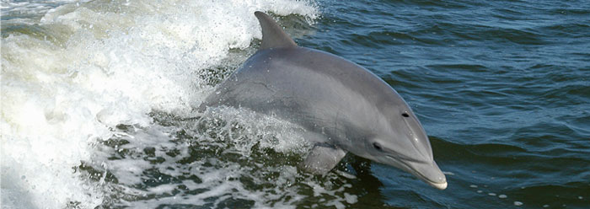Cancer affects many humans and their loved ones, and a new report has found that certain animals are also suffering from higher cancer rates. Sadly, this is what is to be expected in a dying and decaying world.

The technical results of the study are slated to appear in the July edition of *Nature Reviews Cancer*. Lead author Denise McAloose, Chief Pathologist for the Wildlife Conservation Society’s Global Health program, said in a WCS press release that “we now understand that cancer can kill wild animals at similar rates [to humans].”

The WCS study identified California sea lions, dolphins, porpoises, and green sea turtles as creatures with cancer rates that were higher than expected. Most of the described cancers likely have a viral source, but it is possible that human-caused pollution—including loose, carcinogenic chemical waste—could exacerbate the maladies.

Cancers are caused when an error occurs in the genetic machinery that regulates a cell’s growth. Since mutations relentlessly add up during an individual’s lifetime, it is only a matter of time before one of those mutations disrupts a cell’s growth regulation. This could lead to a tumor, which could lead to cancer.

Genesis indicates that human sin resulted in a universal curse, whereby man, animals, and the entire creation “groaneth and travaileth together.” **[Romans 8:22].**

***[Genesis 3:16-19]*** ***To the woman He said: “I will greatly multiply your sorrow and your conception; In pain you shall bring forth children; Your desire shall be for your husband,  And he shall rule over you.”*** ***[17] Then to Adam He said, “Because you have heeded the voice of your wife, and have eaten from the tree of which I commanded you, saying, ‘You shall not eat of it’: “Cursed is the ground for your sake; In toil you shall eat of it All the days of your life.*** ***[18] Both thorns and thistles it shall bring forth for you,  And you shall eat the herb of the field.[19******] In the sweat of your face you shall eat bread  Till you return to the ground, For out of it you were taken; For dust you are, And to dust you shall return.”***

This accurately reflects today’s world, in which cancer is an increasing calamity. Some endangered animals are even facing extinction due to cancer.3

In the bigger picture, fossils show clearly that nature has “deselected” the vast majority of life forms in the past through widespread catastrophes. And now nature continues to “deselect” more through disease. There is therefore no scientific basis for the Darwinian philosophy that living forms find a way to adapt and improve, ever-increasing their repertoires of functional biological mechanisms.

Rather, extinctions are the rule. In almost every animal and plant phylum, there has been a decline in variety, with most varieties having been catastrophically buried and fossilized. The grim reality is that over the long haul, if a created kind can avoid natural disasters, it will eventually succumb to cancer from mutations.

Scientific observation upholds the Bible’s depiction of a world that was created to be very good, but that is now suffering from the increasing effects of decay and corruption. That is not the end of the story, however. For those who have been redeemed through Christ, death will not have the final word. ***[Revelation 21:4]*** ***He will wipe away every tear from their eyes, and death shall be no more, neither shall there be mourning nor crying nor pain anymore, for the former things have passed away.”***



**Answers from page 1**

1. Barnabas [Acts 13:1-3; 14:4]

2. Peter [Acts 2]

3. The apostle John [Revelation 1:9]

4. Levi [Mark 2:14]

