**SERVICE SCHEDULE for September 20, 2020**

**Announcements for the Week** Darryl Griffing

**Morning Service Evening Service**

**Prayer-** Darryl Griffing **Prayer-** Buck Phillips

**Song Leader-** Brandon Esque **Song Leader-** Mark Tally

**-- Comments –** Andy Fuller **Comments –** Curran LaChappelle

-- **Assisting –** Lucian Griffing **Communion –** Connor L.

**-- Assisting –** Ron Bailey

**-- Assisting –** Connor LaChappelle

**-- Assisting –** Jared Davis

**-- Scripture –** Dean Shacklock **Scripture –** Josiah Phillips

**Closing Prayer-** Phillip Dorn **Closing Prayer-** Dan Woodward

**Wednesday Night – September 23, 2020**

**First Prayer–** Connor LaChappelle

**Song Leader –** Brandon Esque

**Invitation –** Buck Phillips

**Closing Prayer –** Cliff Dvis

**September 27 Evening Service** – Richard Boone

**Upcoming Assignments**

|  |  |  |
| --- | --- | --- |
| **September** | **Communion** | **Cleaning** |
| **20** | LaChappelle | Take the time to police your area before you go. |
| **27** | Shacklock | Cheerios and other cereals can draw ants. |

**Think about these things:**

**It takes a child two years to learn to talk--it takes a man all his life to learn how to keep his mouth shut.**

**A bit of love is the only bit that will put a bridle on the tongue.**

**It would be better to leave people wondering why you didn't talk than why you did.**

**If at first you don't succeed, destroy all evidence that you tried.**

**Live connection starting 9AM. CALL (678) 701-5124 Enter PIN: 1234**



***Schedule of Services***

**Sunday: 9 a.m., 10 a.m. & 5 p.m. Wednesday: 7:00 p.m.**

**Wi-Fi Password: church1234**

**This bulletin is published weekly. Edited by Bill McIlvain.**

**Send any articles for the bulletin to** [**Preacher@covingtonchurchofchrist.com**](mailto:Preacher@covingtonchurchofchrist.com)

**Visit us on the web: www.covingtonchurchofchrist.com**



**9441 Bypass, P.O. Box 768, Covington, GA 30015 --- [770] 787-1119**

**Elders: Jason LaChappelle, Bill McIlvain**

**Deacons: Cliff Davin, Darryl Griffing, Buck Phillips**

**September 20, 2020**

***More Blindness***

1. Who was blind for three days after seeing a great light?

2. What judge was blinded by the Philistines?

3. What father of twelve sons was blind in his old age?

4. What did Jesus put in the eyes of a blind man at the pool of Siloam?



***Barbers Don’t Exist***

**From my archives**

A man went to a barbershop to have his hair cut and his beard trimmed. As the barber began to work, they began to have a good conversation. They talked about so many things and various subjects.

When they eventually touched on the subject of God, the barber said: "I don't believe that God exists."

"Why do you say that?" asked the customer.

"Well, you just have to go out in the street to realize that God doesn't exist. Tell me, if God exists, would there be so many sick people? Would there be abandoned children? If God existed, there would be neither suffering nor pain. I can't imagine a loving a God who would allow all of these things."

***Barbers Don’t Exist***

**Continued**

The customer thought for a moment, but didn't respond because he didn't want to start an argument. The barber finished his job and the customer left the shop. Just after he left the barbershop, he saw a man in the street with long, stringy, dirty hair and an untrimmed beard. He looked dirty and un-kept.

The customer turned back and entered the barber shop again and he said to the barber: "You know what? Barbers do not exist."

"How can you say that?" asked the surprised barber. "I am here, and I am a barber. And I just worked o n you!"

"No!" the customer exclaimed. "Barbers don't exist because if they did, there would be no people with dirty long hair and untrimmed beards, like that man outside."

"Ah, but barbers DO exist! What happens is, people do not come to me."

"Exactly!"- Affirmed the customer. "That's the point! God, too, DOES exist! What happens, is, people don't go to Him and do not look for Him. That's why there's so much pain and suffering in the world."



***The Five Finger Prayer***

**Author Unknown**

This is beautiful and it is surely worth making the 5-finger prayer a part of our lives.

1. Your thumb is nearest you. So begin your prayers by praying for those closest to you. They are the easiest to remember. To pray for our loved ones is, as C. S. Lewis once said, a "sweet duty."

2. The next finger is the pointing finger. Pray for those who teach, instruct and heal. This includes teachers, doctors, and ministers. They need support and wisdom in pointing others in the right direction. Keep them in your prayers.

3. The next finger is the tallest finger. It reminds us of our leaders. Pray for the president, military, leaders in business and industry, and administrators. These people shape our nation and guide public opinion. They need God's guidance.

4. The fourth finger is our ring finger. Surprising to many is the fact that this is our weakest finger; as any piano teacher will testify. It should remind us to pray for those who are weak, in trouble or in pain. They need your prayers day and night. You cannot pray too much for them.

5. And lastly comes our little finger; the smallest finger of all which is where we should place ourselves in relation to God and others. As the Bible says, "The least shall be the greatest among you." Your pinkie should remind you to pray for yourself. By the time you have prayed for the other four groups, your own needs will be put into proper perspective and you will be able to pray for yourself more effectively.

Pass this on to someone special

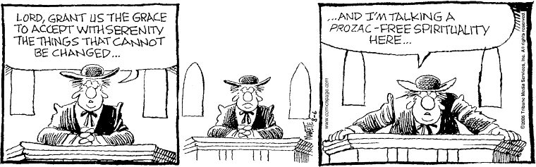



**Answers from page 1**

1. Paul [Acts 9:9]

2. Samson [Judges 16:21]

3. Jacob [Genesis 48:10]

4. Mud [John 9:1-7]

