**SERVICE SCHEDULE for September 19, 2021**

**Announcements for the Week** Darryl Griffing

**Morning Service Evening Service**

**Prayer-** Darryl Griffing **Prayer-** Darryl Griffing

**Song Leader-** Curran LaChappelle **Song Leader-** Jason LaChappelle

**-- Comments –** Mark Tally **Comments –** Ben Wofford

**-- Assisting –** Andy Fuller **Communion –** Phillip Dorn

**-- Assisting –** Jared Davis

**-- Assisting –** Dean Shacklock

**-- Assisting –** Connor LaChapelle

**-- Scripture –** Ben Wofford **Scripture –** Josiah Phillips

**Closing Prayer-** Phillip Dorn **Closing Prayer-** Connor L.

**Wednesday Night – September 22, 2021**

**First Prayer–** Phillip Dorn

**Song Leader –** Buck Phillips

**Invitation –** Curran LaChappelle

**Closing Prayer –** Ben Wofford

**September 26 Evening Service –** Marshall Irvin

**Upcoming Assignments**

|  |  |  |
| --- | --- | --- |
| **September** | **Communion** | **Cleaning** |
| **19** | MacQuilliam | Please Be Considerate |
| **19** | McIlvain | Clean the area around your seat |

**Good Thoughts – Fruit is Singular**

**Galatians 5 lists the "works of the flesh" and contrasts the "fruit of the spirit"… *"Now the works of the flesh are made manifest, which are these: adultery, fornication, uncleanness, lasciviousness, idolatry, witchcraft, hatred, variance, emulations, wrath, strife, seditions, heresies, envying, murders, drunkenness, revellings, and such like...But the fruit of the spirit is love, joy, peace, longsuffering, gentleness, goodness, faith, meekness, temperance" (5:19-21a, 22).***

**In verse 22, the word "fruit" is singular even though it encompasses multiple virtues. The singularity of this word is designed to convey a complete, well-rounded picture of the character of a child of God. – Andrew Lehmann**



***Schedule of Services***

**Sunday: 9 a.m., 10 a.m. & 5 p.m. Wednesday: 7:00 p.m.**

**This bulletin is published weekly. Edited by Bill McIlvain.**

**Send any articles for the bulletin to** [**Preacher@covingtonchurchofchrist.com**](mailto:Preacher@covingtonchurchofchrist.com)

**Visit us on the web: www.covingtonchurchofchrist.com**



**9441 Bypass, P.O. Box 768, Covington, GA30015 --- [770] 787-1119**

**Elders: Jason LaChappelle, Bill McIlvain**

**Deacons: Cliff Davis, Darryl Griffing, Buck Phillips**

**September 19, 2****021**

***Hard To Find Answers***

1. Which of Jacob’s sons had teeth whiter than milk?

2. What prophet mentions multicolored carpets?

3. Who had a throne with purple cushions?

4. What is the shortest prayer in the Biblef?



***Blessings in the Wilderness***

**By David Maxson**

***It was I who knew you in the wilderness, in the land of drought; but when they had grazed, they became full, they were filled, and their heart was lifted up; therefore they forgot me. [Hosea 13:5-6]***

Abraham Lincoln said, "Nearly all men can stand adversity, but if you want to test a man's character, give him power."

When we are in the wilderness we feel helpless. We're hungry. We're thirsty. We're lost and without direction. We're anxious and afraid. We're unsure of ourselves.

And that's a good place to be.



***Blessings in the Wilderness***

**Continued**

When we arrive in the land where the milk and honey are flowing we feel strong. We're full. We're satisfied. We're full of self-confidence and sure of ourselves. We feel bold and powerful.

And that's a dangerous place to be.

In the wilderness we're desperate for God. That's why Paul said he embraced the wilderness, ***"For the sake of Christ, then, I am content with weakness, insults, hardships, persecutions, calamities. For when I am weak, then I am strong." [2 Corinthians 12:10]***

In the land of milk and honey we don't feel the same desperation. That's why James cautions the rich to boast in his humiliation, because ***"like a flower of the grass he will pass away." (James 1:10)***

Is life good for you right now? Be thankful if it is.

But be careful. The land where you dwell is filled with danger.

Thank God for the good things in our lives. Also thank God for the dry places in our journey. They remind us of our need for Him.



***‘Uh-Oh!’***

**By Andy Diestelkamp**

"Uh-oh! I forgot about that part." Perhaps you have uttered words similar to those after inviting people to go with you to a movie or into your home to watch something. It is interesting how our sensitivities to scrupulous standards are heightened when we have invited brethren to be present with us. As uncomfortable as such experiences might be, I believe they are good for us because they remind us that our brother, Jesus, is omnipresent in our homes.

What concerns me is when we quit having those "uh-oh" experiences at times when we should. Scripturally, this is getting to the point of being "past feeling" (Ephesians 4:17-20). Paul tells us that this is the way the world lives being alienated from God with minds that are futile, dark and ignorant. That certainly is not the way we have learned Christ. Thus, if sinful worldly activities no longer elicit "uh-ohs" from us, it would indicate that we are no longer keeping God and His values foremost in our minds. It is those kinds of people that God gives over to a debased mind to do things which are not fitting (Romans 1:28).

We need to re-sensitize ourselves to the immorality that is so often pushed off as art. The so-called poetic or artistic license that is used to violate grammatical or traditional boundaries is also used to violate moral lines. The freedom to express oneself does not include the freedom to harm others. This is understood in relation to certain acts of violence, polluting the environment or even yelling "fire" in a crowded theater. However, it seems that we lack the moral courage to restrict freedoms and choices that harm the unborn, pollute the mind or encourage people to stampede through the wide gate that leads to destruction.

Yes, some will think it strange that we do not run with them in a mad rush to see a certain movie. Some will speak evil of us and disparage the high standards we submit to in Christ. However, we are all going to have to give an account when we stand before the judge of the living and the dead. It would be better to say, "Uh-oh!" now rather than then.



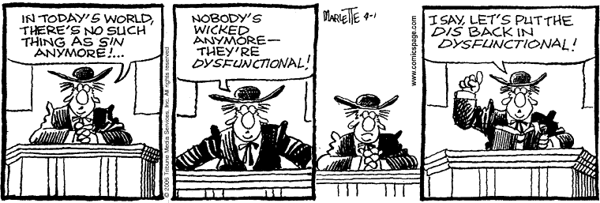

**Answers from page 1**

1. Judah [Genesis 49:12]

2. Ezekiel [Ezekiel 27:24]

3. Solomon [Song of Solomon 3:10]

4. Peter prayed, “lord, save me!” [Matthew 14:30]

