SERVICE SCHEDULE for November 28, 2021
Announcements for the Week Cliff Davis
Morning Service Evening Service
Prayer- Cliff Davis Prayer- Cliff Davis
Song Leader- Roger German Song Leader- Bill McIlvain LaChappelle
-- Comments – Andy Fuller Comments – Connor LaChappelle
-- Assisting – Brandon Esque Communion – Ben Wofford
-- Assisting – John MacQuilliam
-- Assisting – Dean Shacklock
-- Assisting – Jared Davis
-- Scripture – Mark Tally Scripture – Dean Shacklock
Closing Prayer- Ben Wofford Closing Prayer – Dan Woodward
Wednesday Night – December 1, 2021
First Prayer– Ron Bailey
Song Leader – Josiah Phillips
Invitation – Ben Wofford
Closing Prayer – Darryl Griffing
November 28 Evening – Song Origin Service
Upcoming Assignments
November | Communion | Cleaning
28 | Davis | Please Be Considerate
Dec 5 | Hickey | Clean the area around your seat
Good Thoughts –
God so loved the world that He did not send a committee.
Confess Your Faults -- James 5:15 says "confess your sins to one another." Admittedly, confessing your faults and sinful habits will be difficult. When you confess your failings to others, then they can help look out for you.
Singing Class –
There will be a new singing class offered to anyone who would like to learn more about song leading, shape notes and harmony singing in general. The time will be at 4:30 on Sunday evenings.

Schedule of Services

Sunday: 9 a.m., 10 a.m. & 5 p.m. Wednesday: 7:00 p.m.
This bulletin is published weekly. Edited by Bill McIlvain.
Send any articles for the bulletin to Preacher@covingtonchurchofchrist.com
Visit us on the web: www.covingtonchurchofchrist.com

9441 Bypass, P.O. Box 768, Covington, GA 30015 --- [770] 787-1119
Elders: Jason LaChappelle, Bill McIlvain
Deacons: Cliff Davis, Darryl Griffing, Buck Phillips
November 28, 2021
Hugs & Kisses
1. Who poured oil on Saul’s head and kissed him?
2. What aged father kissed one son, mistaking him for the other?
3. Who met Moses in the wilderness and kissed him?
4. When Jacob died, who wept over him and kissed him?

Keep Your Fork
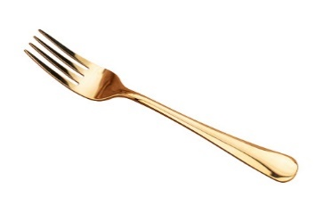
Submitted By Ron Bailey
Today someone asked about my fork tattoo (which most of the time I forget I have) but I’m glad they did. I needed the reminder of what it symbolized. I have a couple friends that are going through tough times right now. I hope they find peace in this message. For those who don’t know what it means, I’ll share the story now. ------------------------
There was a young woman who had been diagnosed with a terminal illness and had been given three months to live. So, as she was getting her things ‘in order,’ she contacted her Preacher and had him come to her house to discuss certain aspects of her final wishes.
Keep Your Fork
Continued
She told him which songs she wanted sung at the service, what scriptures she would like read, and what outfit she wanted to be buried in. Everything was in order and the Pastor was preparing to leave when the young woman suddenly remembered something very important to her.
“There’s one more thing,” she said excitedly.
“What’s that?” came the Preacher’s reply.
“This is very important,’ the young woman continued. ‘I want to be buried with a fork in my right hand.”
The Preacher stood looking at the young woman, not knowing quite what to say.
“That surprises you, doesn’t it?” the young woman asked.
He said, “Well, to be honest, I’m puzzled by the request.”
The young woman explained. “My grandmother once told me this story, and from that time on I have always tried to pass along its message to those I love and those who are in need of encouragement. In all my years of attending socials and dinners, I always remember that when the dishes of the main course were being cleared, someone would inevitably lean over and say, ‘Keep your fork.’ It was my favorite part because I knew that something better was coming, like velvety chocolate cake or deep-dish apple pie. Something wonderful, and with substance!
So, I just want people to see me there in that casket with a fork in my hand and I want them to wonder, ‘What’s with the fork?!’ Then I want you to tell them: ‘Keep your fork. The best is yet to come.”
The Preacher’s eyes welled up with tears of joy as he hugged the young woman goodbye. He knew this would be one of the last times he would see her before her death. But he also knew that the young woman had a better grasp of heaven than he did. She had a better grasp of what heaven would be like than many people twice her age, with twice as much experience and knowledge. She KNEW that something better was coming.
At the funeral people were walking by the young woman’s casket and they saw the cloak she was wearing and the fork placed in her right hand. Over and over, the Preacher heard the question, “What’s with the fork?” And over and over again he smiled.
During his message, the Preacher told the people of the conversation he had with the young woman shortly before she died. He also told them about the fork and about what it symbolized to her. He told the people how he could not stop thinking about the fork and told them they probably would not be able to stop thinking about it either. He was right.
So the next time you reach down for your fork let it remind you, ever so gently, that the best is yet to come. Friends are a very rare jewel, indeed. They make you smile and encourage you to succeed. Cherish the time you have, and the memories you share. Being friends with someone is not an opportunity, but a sweet responsibility
And just remember…keep your fork! -- The BEST is yet to come!
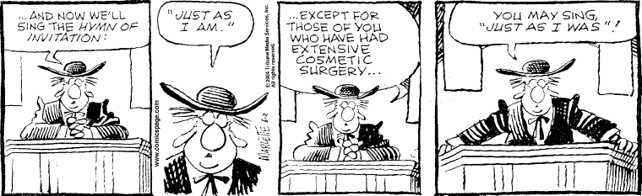


Answers from page 1
1. Samuel [1 Samuel 10:1]
2. Isaac kissed Jacob instead of Esau [Genesis 27:27]
3. Jethro, his father-in-law [Exodus 18:5-7]
4. Joseph [Genesis 50:1]


