SERVICE SCHEDULE for December 5, 2021
Announcements for the Week Buck Phillips
Morning Service Evening Service
Prayer- Buck Phillips Prayer- Buck Phillips
Song Leader- Mark Tally Song Leader- Connor LaChappelle
-- Comments – Darryl Griffing Comments – Andy Fuller
-- Assisting – Andy Fuller Communion – John MacQuilliam
-- Assisting – Cliff Davis
-- Assisting – Phillip Dorn
-- Assisting – Eli Hickey
-- Scripture – Josiah Phillips Scripture – Curran LaChappelle
Closing Prayer- Ron Bailey Closing Prayer- Ben Wofford
Wednesday Night – December 8, 2021
First Prayer– Curran LaChappelle
Song Leader – Ben Wofford
Invitation – Darryl Griffing
Closing Prayer – Dan Woodward
December 26 Evening Song & Prayer Service
Upcoming Assignments
December | Communion | Cleaning
5 | Hickey | Please Be Considerate
12 | Wofford | Clean the area around your seat
Good Thoughts –
If you give the Devil an inch & he'll be a ruler. Never give the devil a ride -- he will always want to drive.
Anybody can give advice--the trouble comes in finding someone interested in using it.
Exercise daily -- walk with the Lord.
Suffering from truth decay? Brush up on your Bible.
Singing Class –
The singing class is still offered to anyone who would like to learn more about song leading, shape notes and harmony singing in general. The time will be at 4:30 on Sunday evenings. Can you Name That Tune?

Schedule of Services

Sunday: 9 a.m., 10 a.m. & 5 p.m. Wednesday: 7:00 p.m.
This bulletin is published weekly. Edited by Bill McIlvain.
Send any articles for the bulletin to Preacher@covingtonchurchofchrist.com
Visit us on the web: www.covingtonchurchofchrist.com

9441 Bypass, P.O. Box 768, Covington, GA30015 --- [770] 787-1119
Elders: Jason LaChappelle, Bill McIlvain
Deacons: Cliff Davis, Darryl Griffing, Buck Phillips
December 5, 2021
The Company of Apostles
1. Who requested special places for themselves in the kingdom?
2. Who brought Nathaniel to Jesus?
3. Who called Jesus, “My Lord and my God”?
4. Who were the “sons of thunder”?

The Great Physician
By Anonymous
Welcome to the Great Physician - Office hours are as you come, - He's a Specialist in all problems - And His day is never done. He can heal a heart that's broken - He can mend the spirit, too, - No matter what your ailment - He does have the cure for you.
His fee for service never alters - He serves rich and poor as well, - He's our one chance for Salvation, - He alone saves us from Hell.
There's no fee for services rendered - All He asks is that we obey and believe, - That He bled and died to save us - And all His blessings we will receive.
Do you have a special problem - That is troubling you this hour? - Then just simply leave it with Him - You can find no greater power. Don't delay in seeking treatment - Please, my friend, don't hesitate, - For His office is soon closing - And He'll shut and lock the gate.
I wouldn't want you to suffer - While the Doctor's so close by, - Your whole life will be much better - If my Physician you will try.

Christ’s Kingdom is Already Here
By Edwin Crozier
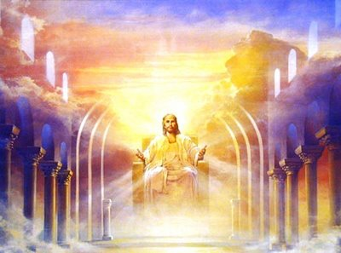
Many Christians are scared of Revelation.
Admittedly, it is a different kind of book. We aren’t used to its apocalyptic genre. It employs figures we aren’t readily familiar with.
It uses a style that is not common to us. However, I fear that many Christians are afraid because they know “we” are supposed to believe Christ’s kingdom is already here, but they think Revelation may actually teach what the Premillennialists say about it. They are afraid that if they really study the book, it will cause them to believe we are still waiting for the kingdom.
No doubt, we could spend weeks and weeks studying all of Revelation to defuse the Premillennial interpretation. However, despite some of the more difficult, complex, and symbolic passages that the Premillennialists use to defend their doctrine, the book actually begins with some very clear-cut statements that lay a foundation for the whole book. They lay a foundation that should mold our interpretation of the rest of the book.
Revelation 1:5-6 says, “…Jesus Christ the faithful witness, the firstborn of the dead, and the ruler of kings on earth. To him who loves us and has freed us from our sins by his blood and made us a kingdom, priests to his God and Father, to him be glory and dominion forever and ever. Amen.”
Just as Jesus is already the firstborn of the dead, He is already the ruler of kings on earth. He is already king. Not only that, but He has already made us into a kingdom. We are not waiting for the kingdom, we are already in the kingdom if we have been set free from our sins by Christ. As Paul said in Colossians 1:13, we are not waiting for Christ’s kingdom, we have already been transferred into it.
Then Revelation 1:9 says, “I, John, your brother and partner in the tribulation and the kingdom and the patient endurance that are in Jesus…”
John was not writing about some future tribulation. He was already in it, partnering in it alongside his readers. He was not writing about some future kingdom. He was already in it, partnering in it alongside his readers. Back in Mark 9:1, Jesus said, “Truly, I say to you, there are some standing here who will not taste death until they see the kingdom of God after it has come with power.” John was there that day. His words in Revelation 1:9 demonstrate Jesus told the truth. John was still alive and the kingdom of God had already come.
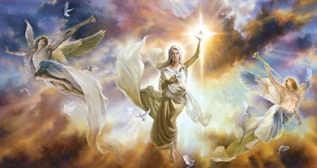
I know our Premillennial friends like to jump to Revelation 20, and there are certainly a myriad of positions taken on what that chapter means. However, whatever we believe it means, we can’t make it deny the very foundation of John’s book. John’s foundation was that the kingdom was already established and enduring a great tribulation, it was not looking forward to one in the dim and distant future.
The kingdom of Jesus is here; we are not waiting for it. We need to get into it and stay in it.

Answers from page 1
1. James and John [Mark 10:39]
2. Philip [John 1:43-46]
3. Thomas [John 20:28]
4. James and John [Mark 3:17]


