SERVICE SCHEDULE for February 20, 2022
Announcements for the Week Darryl Griffing
Morning Service Evening Service
Prayer- Darryl Griffing Prayer- Darryl Griffing
Song Leader- Mark Tally Song Leader- Curran LaChappelle
-- Comments – Eli Hickey Comments – Buck Phillips
-- Assisting – Connor LaChappelle Communion – Connor LaChappelle
-- Assisting – Cliff Davis
-- Assisting – Dean Shacklock
-- Assisting – Jared Davis
-- Scripture – Phillip Dorn Scripture – Josiah Phillips
Closing Prayer- John MacQuilliam Closing Prayer- Phillip Dorn
Wednesday Night – February 23, 2022
First Prayer– Brandon Esque
Song Leader – Buck Phillips
Invitation – Connor LaChappelle
Closing Prayer – Andy Fuller
February 27 Evening Service – Curran LaChappelle
Upcoming Assignments
February | Communion | Cleaning
20 | Bailey | Please Be Considerate
27 | Fuller | Clean the area around your seat
Lot’s Wife –
The Sunday School teacher was describing how Lot's wife looked back and turned into a pillar of salt, when little Jason interrupted, 'My Mommy looked back once while she was driving,' he announced triumphantly, 'and she turned into a telephone pole!' [Thanks to J.G.]
Integrity-
Integrity is telling myself the truth. And honesty is telling the truth to other people. ― Spencer Johnson
If you don't know where you are going, you'll end up someplace else. ―
A great many people think they are thinking when they are merely rearranging their prejudices. ― William James

Schedule of Services

Sunday: 9 a.m., 10 a.m. & 5 p.m. Wednesday: 7:00 p.m.
This bulletin is published weekly. Edited by Bill McIlvain.
Send any articles for the bulletin to Preacher@covingtonchurchofchrist.com
Visit us on the web: www.covingtonchurchofchrist.com

9441 Bypass, P.O. Box 768, Covington, GA30015 --- [770] 787-1119
Elders: Jason LaChappelle, Bill McIlvain
Deacons: Cliff Davis, Darryl Griffing, Buck Phillips
February 20, 2022
Who Said That?
1. Jesus Christ makes you whole; arise, and make your bed.
2. Why is my pain perpetual, and my wound incurable, which refuses to be healed?
3. And after you shall arise another kingdom inferior to you, and another third kingdom of brass, which shall bear rule over all the earth.
4. We have found him, of whom Moses in the law, and the prophets, did write, Jesus of Nazareth, the son of Joseph.

Stumbling Over Baptism
By Andy Diestelkamp
What a stumbling block baptism is! Oh, I recognize that there are other aspects of God's will that are likewise rejected, but in my experience no one thing is more often refused than is baptism into Jesus Christ for the remission of sins.
Too often it is rejected with very little scriptural defense. Not because of some scriptural conviction; but because, as one woman wrote me, "I know I am saved, and there is absolutely nothing you could say to me to convince me otherwise."
Stumbling Over Baptism
Continued
My heart aches. It aches not because what I say is being rejected, but because the "better felt than told" wall of defense is usually impenetrable, even by the word of God.
Occasionally, scriptural effort is put forth to show reasons why baptism is not for the remission of sins. A popular form of argument is to show that it is by grace that we are saved and not by works. Baptism is relegated to the realm of works and thus marginalized as important, but not essential to salvation.
Have they not read, "For as many of you as were baptized into Christ have put on Christ" (Galatians 3:27)? We do not put on Christ by our "own righteousness," but we do put on Christ in baptism. Therefore, baptism is not our "own righteousness." Just as surely as we are sons of God through faith (vs. 26) we clothe ourselves with Christ in baptism. As we cannot rightly be called sons of God without faith, neither can we put on Christ or be in Christ without baptism.
It is by God's grace alone that baptism washes sins away (Acts 22:16). Baptism is not for those who trust in themselves and their perfection, but for those who trust in God.
Paul writes that we are "buried with [Christ] in baptism, in which [we] also were raised with Him through faith in the working of God, who raised Him from the dead" (Colossians 2:12). Baptism into Christ is presented consistently as an act of faith in God, not in water, my perfection, or my works. Saving baptism is an act done in faith in the working of God. It is nothing over which to stumble. It is a righteous act of faith to which we must submit.

A Pool Table In Mayberry
By Jim Jonas
On a recent episode of Andy Griffith, the church in Mayberry had been bequeathed five hundred dollars by a deceased member. The finance committee then invited suggestions from the “parishioners” on how the money should be spent.
Aunt Bea, spokeswoman for the ladies’ choir, made an emotional appeal for new choir robes, even threatening to disband the choir if the committee didn’t accede to her demands.
Howard Sprague, ever the practical sort, argued for repair on the building as a faulty drainage problem had caused the foundation to settle five degrees off level.
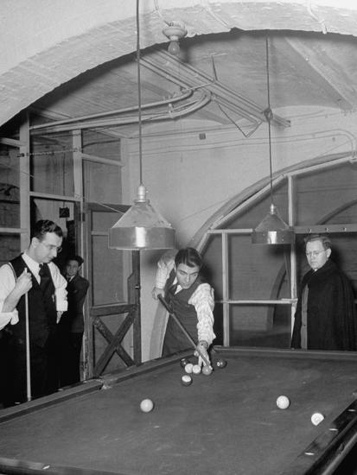
The third suggestion was timidly offered by another member, who noted that his request was not quite so “religious” as Aunt Bea’s choir robes. This fellow wanted the church to buy a pool table and place it in the basement. His reasoning? That it might attract more men to the socials sponsored by the church.
The debate then began between leveling the foundation and buying the choir robes – the suggestion of the pool table was met with disdain and dismissed. So how would this sticky situation be handled today?
First, the acquisition of a pool table would not be looked upon in disfavor by modern churches which spend millions of dollars to build sports and recreation annexes. The idea of using worldly “bait” to attract non-Christians has become a staple in post-Mayberry religious practice.
Secondly, Aunt Bea would have a hissy-fit at the thinly veiled pop-rock productions that have replaced her choir’s solemn hymns, but she probably wouldn’t realize that the same lack of Bible authority that permits choirs (and robes) also permits secular music ministries.
Finally, as chairman of the finance committee, Sheriff Taylor was to cast the tie-breaking vote between Aunt Bea and Howard – a lose/lose proposition. In one scene, as Aunt Bea is serving Andy all of his favorite dishes, Opie whispers, “Pa, is this what they call ‘lobbying’?”
Mayberry politics are still alive and well today. Even among brethren lobbying is sometimes put before love. The lesson from Mayberry: some things never change, other things get worse.

Answers from page 1
1. Peter [Acts 9:34]
2. Jeremiah [Jeremiah 15:18]
3. Daniel [Daniel 2:39]
4. Philip [John 1:45]


