SERVICE SCHEDULE for February 6, 2022
Announcements for the Week Buck Phillips
Morning Service Evening Service
Prayer- Buck Phillips Prayer- Buck Phillips
Song Leader- Roger German Song Leader- Curran LaChappelle
-- Comments – Andy Fuller Comments – Connor LaChappelle
-- Assisting – Brandon Esque Communion – Ben Wofford
-- Assisting – Dean Shacklock
-- Assisting – John MacQuilliam
-- Assisting – Jared Davis
-- Scripture – Curran LaChappelle Scripture – Josiah Phillips
Closing Prayer- Ben Wofford Closing Prayer- Dan Woodward
Wednesday Night – February 9, 2022
First Prayer– Phillip Dorn
Song Leader – Ben Wofford
Invitation – Curran LaChappelle
Closing Prayer – Dan Woodward
February 27 Evening Service – Curran LaChappelle
Upcoming Assignments
February | Communion | Cleaning
6 | MacQuilliam | Please Be Considerate
13 | Tucker | Clean the area around your seat
Giving Up On Sports –
Here’s why I’m giving up on sports of all kind:
1. Every time I went, they asked for money.
2. The people I sat next to didn't seem friendly.
3. The seats were too hard and not comfortable at all.
4. I went to many games but the coach never came to call on me.
5. The game went into overtime and I was late getting home.
6. They had music I'd never heard before and it wasn't my style of music.
7. I was forced to go to games by my parents when I was growing up.
8. I suspect that I was sitting next to some hypocritical fans. They came to see their friends and they talked during the whole game.

Schedule of Services

Sunday: 9 a.m., 10 a.m. & 5 p.m. Wednesday: 7:00 p.m.
This bulletin is published weekly. Edited by Bill McIlvain.
Send any articles for the bulletin to Preacher@covingtonchurchofchrist.com
Visit us on the web: www.covingtonchurchofchrist.com

9441 Bypass, P.O. Box 768, Covington, GA30015 --- [770] 787-1119
Elders: Jason LaChappelle, Bill McIlvain
Deacons: Cliff Davis, Darryl Griffing, Buck Phillips
February 6, 2022
Who Said That?
1. Do violence to no man, neither accuse any falsely; and be content with your wages.
2. In the name of Jesus Christ of Nazareth rise up and walk.
3. What I have written, I have written.
4. A man can receive nothing, except it be given him from heaven.

T. Rex Teeth Take A Bite Out Of Evolution
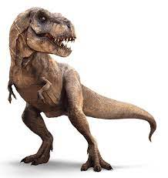
By Brian Thomas
A set of fossilized Tyrannosaurus Rex teeth was found in a rock layer that it had no business being in, according to evolutionary interpretations. Discovered in Hyogo, Japan, the teeth came from a 15-foot-tall dinosaur entombed in early Cretaceous rock, supposedly deposited 140 million years ago.
The problem is that T. Rex Dinosaurs of this large size are not supposed to have evolved until about 30 million years later. Thus, what is “known” about dinosaurs must undergo drastic revision.

T. Rex Teeth Take A Bite Out Of Evolution
Continued
Young-earth creation geologists have long held that most sedimentary strata—including the Cretaceous layer in which these teeth were found—resulted from waterborne deposits during Noah’s Flood that may harbor fossils from a particular local environment, but do not represent a particular “era.”
However, an oversized T. Rex found in the “wrong age” and the “wrong time” doesn’t surprise creation scientists. If the rock that these T. Rex fossil teeth was found in was indeed deposited during the year-long Noahic Flood, then it is easy to explain why a large dinosaur is found mixed in with smaller ones.
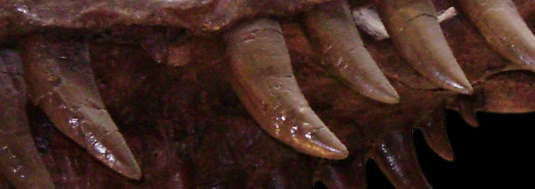
There never was an “era of smaller T-rex dinosaurs,” but there was a massive Flood that wiped out whole environments, layering and sorting sediments and fossilizing the creatures buried therein.


Imitated, But Never Duplicated
By Brian Thomas
All the dust of the earth became gnats in all the land of Egypt. The magicians tried by their secret arts to produce gnats, but they could not... Then the magicians said to Pharaoh, "This is the finger of God." [Exodus 8:18-19]
God's power can be imitated but never duplicated. Take, for example, the human body. It's a marvelous machine. It has eyes and ears to see and hear. It has a digestive system, a circulatory system, a nervous system, a system of bones and ligaments, etc. It is equipped with microscopic organisms that help fend off infection. Take any one part of the body and what you have is an absolute marvel of design.
Scientists and engineers have developed mechanical devises that do similar things to the human body. We have cameras that are self-focusing like the human eye. We have computers equipped with systems of communication and systems that fight against infection (we even call it "antivirus" software). We have designed engines that run on different types of fuel.
None of these inventions by man can possibly compare to the complexity and the efficiency of the body. I do not know of antivirus software that is as adaptable as the human body at attacking different types of infections. There is not an engine made by man that can take such a variety of fuels to run on.
Engineers look at the structure of our bones and are amazed. They look at the sensitivity of our eyes and ears and are in awe. They study how precisely our motor skills work compared to manmade robotics and are astonished.
Truly, this is the finger of God! Praise the Lord for we are fearfully and wonderfully made!

Remember Me?
By David Roper
"I'm the fellow who comes into your church building and stands at the back, looking for a place to sit with no one asking to help. I'm the fellow who crawls over three members seated on the end of the pew, who will not move down. I'm the fellow who makes his way quietly to the exit at the close of the service, passing members enjoying their visits with each other. I'm the fellow you didn't greet and meet. I'm the fellow who leaves with no word of complaint. I'm the fellow who will never come back."
"Be not forgetful to entertain strangers: for thereby some have entertained angels unawares" (Hebrews 13:2).

Answers from page 1
1. John the Baptist [Luke 3:14]
2. Peter [Acts 3:6]
3. Pilate [John 19:22]
4. John the Baptist [John 3:27]


