SERVICE SCHEDULE for January 15, 2023
Announcements for the Week Darryl Griffing
Morning Service Evening Service
Prayer- Darryl Griffing Prayer- Darryl Griffing
Song Leader- Mark Tally Song Leader- Buck Phillips
-- Comments – Cliff Davis Comments – Andy Fuller
-- Assisting – Jared Davis Communion – Ben Wofford
-- Assisting – Brandon Esque
-- Assisting – Andy Fuller
-- Assisting – Eli Hickey
-- Scripture – Josiah Phillips Scripture – Dan Woodward
Closing Prayer- Phillip Dorn Closing Prayer- Phillip Dorn
Wednesday Night – January 18, 2023
First Prayer– Phillip Dorn
Song Leader – Buck Phillips
Invitation – Eli Hickey
Closing Prayer – Andy Fuller
January 22 Evening Service – Buck Phillips
Upcoming Assignments
January | Communion | Cleaning
15 | Hickey | Please Be Considerate
22 | Griffing | Clean the area around your seat
Memory Verse – Ecclesiastes 3:1
To everything there is a season, A time for every purpose under heaven:
Good Thoughts –
May your trials last as long as your disobedience.― Daryl Baugh
Christianity would have lacked a great essence without the Bible. A Christian who seldom devotes a little time to read the Bible is with a great question mark. ― Ernest Agyemang Yeboah
The value of the Bible lies in its heartfelt simplicity. ― Jason E. Royle

Schedule of Services

Sunday: 9 a.m., 10 a.m. & 5 p.m. Wednesday: 7:00 p.m.
This bulletin is published weekly. Edited by Bill McIlvain.
Send any articles for the bulletin to Preacher@covingtonchurchofchrist.com
Visit us on the web: www.covingtonchurchofchrist.com

9441 Bypass, P.O. Box 768, Covington, GA30015 --- [770] 787-1119
Elders: Jason LaChappelle, Bill McIlvain
Deacons: Cliff Davis, Darryl Griffing, Buck Phillips
January 15, 2023
More About Kings
1. What king of Israel reigned only seven days and killed himself by burning down his palace around him?
2. What king of Ethiopia was supposed to aid Hezekiah in breaking the power of the Assyrians?
3. Who led Israel into sin by allowing his evil wife to introduce Baal worship into the country?
4. Who was the last King of Israel?

Check Our Motives
By David Maxson
And Joash did what was right in the eyes of the LORD all the days of Jehoida the priest...Now after the death of Jehoida the princes of Judah came and paid homage to the king. Then the king listened to them. And they abandoned the house of the LORD, the God of their fathers, and served the Asherim and the idols. [2 Chronicles 24:2, 17-18]
How do we react when we hear about...
- A sweet, obedient young lady who goes off to college and lives a reprobate life?
- A popular Bible class teacher who is caught soliciting prostitutes on business trips.
- A preacher who recently stopped preaching is found to have an addiction to drugs.
Check Our Motives
Continued
Quite naturally, we ask the question, "Why would good people like these do such evil things?" But things are not always so simplistic. Sometimes we need to consider things from the opposite point of view and ask, "Why were those people doing good things before they did evil?"
We typically believe that people act from pure motives (which is what love does, 1 Corinthians 13:7). We think that good young people are righteous out of a sincere love for God. We believe deacons teach the Bible because they care about truth. We trust that preachers preach because they have a genuine love for the lost.
But our trust is not always well founded. What we see might be merely an illusion. Obedience doesn't always come from a desire to please the Lord. Sometimes there is an ulterior, selfish motive behind obedience.
The truth is revealed when the true motive for obedience is taken away. God's watchful eye is always there (whether we are in college, on a business trip, in or out of the pulpit, etc.), and can never be taken away. Selfish motives are not always there.
When our desire is something other than pleasing the Lord, then the moment that motivation is taken away we revert to who we really are. That should be a frightening thought to all of us. It should cause us all to check our motives.
Create a clean heart in us, O God, and renew a steadfast spirit within us

Knowing Satan’s Moves
By Anthony Evans
If you have ever seen a wrestling match, you know it is not pretty. It is sweaty, sticky, dirty, and painful. When you wrestle, you get down and get dirty. There is no halfhearted involvement. You give it everything you’ve got, or you lose.
I know a bit about wrestling because my brother, Arthur, was the Maryland state wrestling champion in his weight class. At his championship match my brother weighed in at about 230 pounds and was going up against the three-time Maryland state champion who out-weighed him by 35 pounds. Before the match, a reporter asked, ‘Who is the toughest wrestler in this room?’
My brother, humble fellow that he is, said, “You are looking at him!”
The reporter looked at him and asked, “What makes you think you are so tough? You are about to fight the man who has won the state championship three times in a row.”
My brother replied with a very insightful comment, “I know. He is bigger and perhaps stronger than I am, but I know his methods.”
We are in a similar fight against Satan. Just as my brother needed to learn his opponent’s moves, we need to understand Satan’s moves. We need to know how he operates, so that we can prepare ourselves to resist in the evil day, and having done everything, to stand firm Ephesians 6:13. No place in Scripture reveals Satan’s schemes better than Genesis 3, which records Satan’s initial contact with man. As the story unfolds, we clearly see Satan’s strategy to ruin the human race.”
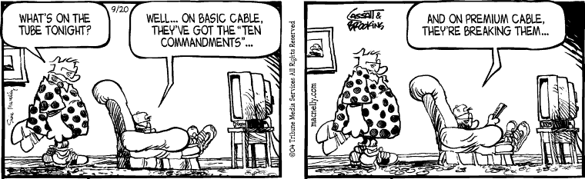



Answers from page 1
1. Zimri [1 Kings 16:15-18]
2. Tirhaka [2 Kings 19:9]
3. Ahab [1 Kings 16:29-33]
4. Hoshea [2 Kings 17:4]


