SERVICE SCHEDULE for January 1, 2023
Announcements for the Week Cliff Davis
Morning Service Evening Service
Prayer- Cliff Davis Prayer- Cliff Davis
Song Leader- Eli Hickey Song Leader- Jason LaChappelle
-- Comments – Buck Phillips Comments – Buck Phillips
-- Assisting – Andy Fuller Communion – Phillip Dorn
-- Assisting – Brandon Esque
-- Assisting – Ron Bailey
-- Assisting – Jared Davis
-- Scripture – Ben Wofford Scripture – Ron Bailey
Closing Prayer- Darryl Griffing Closing Prayer- Curran LaChappelle
Wednesday Night – January 4, 2023
First Prayer–Brandon Esque
Song Leader – Josiah Phillips
Invitation – Buck Phillips
Closing Prayer – Dan Woodward
January 1 Evening Service – Connor LaChappelle
January 22 Evening Service - TBD
Upcoming Assignments
January | Communion | Cleaning
1 | Shacklock | Please Be Considerate
8 | Phillips | Clean the area around your seat
Memory Verse – Psalm 53:6
Whenever I am afraid, I will trust in You.
Good Thoughts –
Why is a car's Windshield so large & the Rear View Mirror so small? Because our PAST is not as important as our FUTURE. So, Look Ahead and Move on.
Consistency???--Some parents told me that they let their children make up their own minds about going to church service, but whipped them because they didn't want to go to school.

Schedule of Services

Sunday: 9 a.m., 10 a.m. & 5 p.m. Wednesday: 7:00 p.m.
This bulletin is published weekly. Edited by Bill McIlvain.
Send any articles for the bulletin to Preacher@covingtonchurchofchrist.com
Visit us on the web: www.covingtonchurchofchrist.com

9441 Bypass, P.O. Box 768, Covington, GA30015 --- [770] 787-1119
Elders: Jason LaChappelle, Bill McIlvain
Deacons: Cliff Davis, Darryl Griffing, Buck Phillips
January 1, 2023
Mountain Trivia
1. Where was Moses buried?
2. Where did Jacob and Laban make their covenant?
3. Where did Elijah go when he fled from Jezebel?
4. Where did Aaron die?

No Time Like The Present
By Steve Klein
The old saying is that the past is a canceled check, and the future is a promissory note; only the present is cash on hand. The year of our Lord 2011 is in the record books. Nothing about it can be changed. The year 2012 lies before us like a clean canvas before a blind painter. Who knows how it will look when finished? The only moment of time we can do anything about is the moment we're in right now. There is no time like the present because it is the only time that we really own.
We must leave the past in the past. We can learn from our past, but we mustn't live in it. Perhaps our better days are behind us, but even so, we cannot go back. We are instructed, "Do not say, 'Why were the former days better than these?' For you do not inquire wisely concerning this." (Ecclesiastes 7:10).

No Time Like The Present
Continued
Perhaps our former days are filled with regrets. Paul's former days were (1 Timothy 1:13-15). We cannot change them. We can get forgiveness if needed, and we can choose to do better today, but we cannot go back.
We must prepare for the future, but live in the present. The future is uncertain. We do not have full control of it. "You do not know what will happen tomorrow" (James 4:14). Tomorrow is only ours if the Lord wills (James 4:13; Luke 12:16-20).
The apostle Paul's approach toward both past and future is ideal. He said, "Brethren, I do not count myself to have apprehended; but one thing I do, forgetting those things which are behind and reaching forward to those things which are ahead, I press toward the goal for the prize of the upward call of God in Christ Jesus" (Philippians 3:13-14). Paul forgot the past, reached toward the future, but lived in the present. Notice the use of the present tense in the preceding verse: "I do not count . . . one thing I do . . . forgetting . . . reaching . . . I press."
What are you doing with the present? Are you making the most of this day and doing your best to serve the Lord in this moment of time? Live in the moment. The Bible says, "Whatever you do, do it heartily, as to the Lord" (Colossians 3:23a). And, "Whatever your hand finds to do, do it with your might" (Ecclesiastes 9:10). And a poet wrote . . .
Today is mine to do with what I will
Today is mine my own special cup to fill
To die a little that I might learn to live
To take from life that I might learn to give
Today is mine
Like most men I cursed the present to avoid the peace of mind
And raise my thoughts beyond tomorrow
and vision there more peace of mind
But as I view this day around me I can see the fool I've been
For today's the only garden we can tend
Today is mine
Getting Rich Quick
By Op Ed
The internet is full of sites that promote making a six figure part-time income with little or no work on your part. It is easy to convince ourselves that all we have to do is to find that “Golden Ticket” that will make all of our financial cares go away.
My grandmother gave me the best advice when I was younger, and it applies today.
“The only time success comes before work is in the dictionary!”

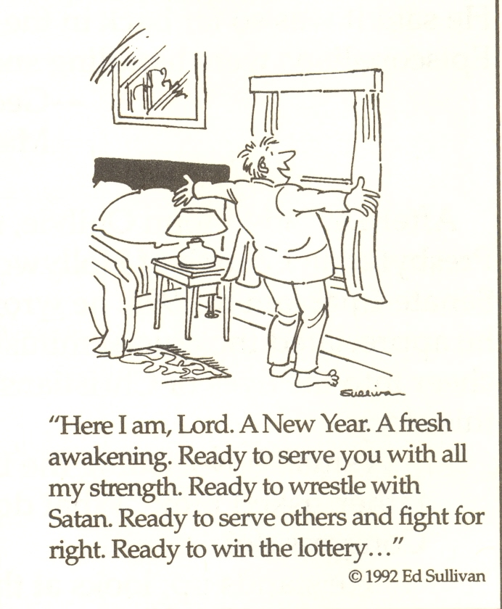


Answers from page 1
1. Pisgah [Deuteronomy 34:5-6]
2. Gilead [Genesis 31:20-49]
3. Horeb [1 Kings 19:8]
4. Mount Hor [Numbers 20:25-29]


