SERVICE SCHEDULE for January 29 2023
Announcements for the Week Buck Phillips
Morning Service Evening Service
Prayer- Buck Phillips Prayer- Buck Phillips
Song Leader- Eli Hickey Song Leader- Jason LaChappelle
-- Comments – Ben Wofford Comments – Darryl Griffing
-- Assisting – Andy Fuller Communion – Phillip Dorn
-- Assisting – Brandon Esque
-- Assisting – Ron Bailey
-- Assisting – Jared Davis
-- Scripture – Ernesto Almazan Scripture – Ron Bailey
Closing Prayer- Dan Woodward Closing Prayer- Curran LaChappelle
Wednesday Night – February 1, 2023
First Prayer– Ron Bailey
Song Leader – Josiah Phillips
Invitation – Darryl Griffing
Closing Prayer – Dan Woodward
January 29 Evening Song Origin Service
Upcoming Assignments
January | Communion | Cleaning
29 | Land | Please Be Considerate
Feb 5 | Wofford | Clean the area around your seat
Memory Verse – Ecclesiastes 3:1
To everything there is a season, A time for every purpose under heaven:
A Conversation –
Mortal: What is a million years like to you? God: Like one second.
Mortal: What is a million dollars like to you? God: Like one penny.
Mortal: Can I have a penny? God: Just a second.
A Bargain – A man and his young son went to church, and when they came out the father was complaining that the service was too long, the preacher was no good, and the singing was off-key. Finally the little boy said, "Daddy, I thought it was pretty good for a dollar."

Schedule of Services

Sunday: 9 a.m., 10 a.m. & 5 p.m. Wednesday: 7:00 p.m.
This bulletin is published weekly. Edited by Bill McIlvain.
Send any articles for the bulletin to Preacher@covingtonchurchofchrist.com
Visit us on the web: www.covingtonchurchofchrist.com

9441 Bypass, P.O. Box 768, Covington, GA30015 --- [770] 787-1119
Elders: Jason LaChappelle, Bill McIlvain
Deacons: Cliff Davis, Darryl Griffing, Buck Phillips
January 29, 2023
Confessions
1. What scribe bowed in front of the temple and confessed the sins of Israel while the people around him wept bitterly?
2. What young man confessed his riotous living to his father?
3. Who confessed Israel’s sins when he learned that Jerusalem’s walls were in ruins?
4. Who was visited by the angel Gabriel while he was confessing his sins?

Wall Street Woes
By David Maxson
When the wicked dies, his hope will perish, and the expectation of wealth perishes too. [Proverbs 11:7]
It's been a crazy couple of weeks on Wall Street. Worries over the down grade of the nation's credit rating rattled investors and sent stocks into a decline.
Should we be afraid? It may be that some of us will not be seeing much of our retirement. It is not likely, but if significant changes are not made in the next several years, some of us may not be able to retire at all.

Wall Street Woes
Continued
The child of God does not worry about such things as others do because his hopes and dreams are not tied to this life. His hopes are in eternity. He has the long view in mind. Eternity, to him, is a long line stretching out as long as the mind can imagine.
This life is just a dot on that line. It is so small that it is barely recognizable. It is a vapor, a warm breath on a frosty morning. This life, to the child of God, is nothing.
So, America's credit rating and the whole economy could go in the toilet. So what? It's just a dot on the line. Our eyes are on the line that stretches to eternity.
And as for the One who is in charge of our eternal investment, his credit rating is flawless!
We are witnessing just how fragile our earthly treasures truly are. May this economic crisis develop a long term perspective in all of us. Help us to trust in the Lord more and less in ourselves.

Defeating Sin In Your Life
By David Maxson
The fear of the LORD is hatred of evil [Proverbs 8:13]
There are two ways to keep sin out of our lives: isolation and insulation.
With isolation we are taking away the opportunity to sin by removing ourselves from temptation. With insulation we are removing the desire to sin by strengthening our relationship with God.
I believe both are necessary if we are going to overcome sin in our life. However, I believe that the most crucial defense we have against sin is a strong relationship with God. Our relationship with God is similar to the relationship between a husband and wife.
In marriage we must avoid situations where we will be tempted by the opposite sex, but to truly make a marriage affair-proof attention must be paid to nurturing the relationship. If we provide for each other emotionally and physically, it will be much more difficult for Satan to cause our hearts to wander.
Is God first in your heart? Do you find everything you need in him? Is worship a priority in your life? Do you remain in constant communication with him through prayer and Bible study?
If not, it doesn't matter how effective you are at removing temptation from your life, the desire for sin will still be there. To win the battle you must learn to love the things God loves and to hate the things God hates, and that happened only when we develop a deep and intimate relationship with him.
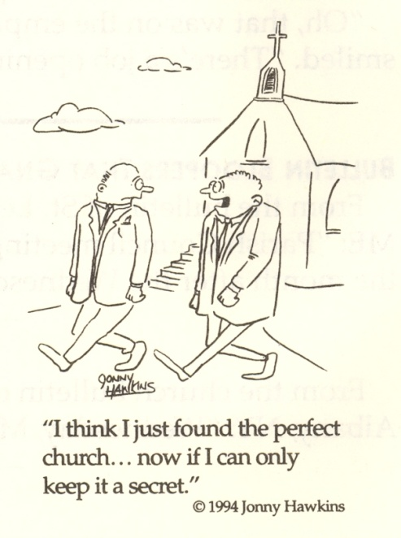

How long should we keep the Good News a secret?
We have knowledge of the best deal that man can take advantage of and we need to share it with our friends and family.
We may be quick to show them how to save a quarter on a loaf of bread, so why not show them how to save their eternal soul?
Let’s do what we can to invite them to come with us to services

Answers from page 1
1. Ezra [Ezra 10:1]
2. The Prodigal Son [Luke 15:18]
3. Nehemiah [Nehemiah 1:6]
4. Daniel [Daniel 9:20]


