SERVICE SCHEDULE for September 17, 2023
Announcements for the Week Buck Phillips
Morning Service Evening Service
Prayer- Buck Phillips Prayer- Buck Phillips
Song Leader- Mark Tally Song Leader- Ben Wofford
-- Comments – Cliff Davis Comments – Darryl Griffing
-- Assisting – Andy Fuller Communion – Ron Bailey
-- Assisting – Jared Davis
-- Assisting – Eli Hickey
-- Assisting – Brandon Esque
-- Scripture – Brandon Anderson Scripture – Dan Woodward
Closing Prayer- Phillip Dorn Closing Prayer- Phillip Dorn
Wednesday Night – September 203, 2023
First Prayer– Phillip Dorn
Song Leader – Cohen Esque
Invitation – Eli Hickey
Closing Prayer – Andy Fuller
September 17 Gospel Meeting - Nolan Glover
September 24 Evening Song Origin Service
Upcoming Assignments
September | Communion | Cleaning
17 | Almazan | Please Be Considerate
17 | K. Fuller | Clean the area around your seat
Memory Verse – Psalm 33:10
The LORD brings the counsel of the nations to nothing: He makes the plans of the peoples of no effect.
Gospel Meeting This Week – September 17 thru 20
One of the preachers that we support will be conducting a series of Scriptural lessons for us stating today and continuing each evening at 7:00PM on Monday thru Wednesday. Many of you may have heard about Nolan Glover. Now we will have a chance to hear lessons from him. Make every effort to attend this series of scriptural lessons and be sure to bring your friends.

Schedule of Services

Sunday: 9 a.m., 10 a.m. & 5 p.m. Wednesday: 7:00 p.m.
This bulletin is published weekly. Edited by Bill McIlvain.
Send any articles for the bulletin to Office@covingtonchurchofchrist.com
Visit us on the web: www.covingtonchurchofchrist.com

9441 Bypass, P.O. Box 768, Covington, GA30015 --- [770] 787-1119
Elders: Jason LaChappelle, Bill McIlvain
Deacons: Cliff Davis, Darryl Griffing, Buck Phillips
September 17, 2023
Gospel Meeting

A Series of Scriptural Lessons Presented By
Nolan Glover of Kennett, Missouri
Sunday, September 17, 2023 at 9:00 AM “Like Minded Brethren”
at 10:00 AM “Standing Out from the World”
at 5:00 PM “Emphasizing Fundamental Truth”
Monday at 7:00 PM “Why Take a Chance on Eternity?”
Tuesday at 7:00 PM “Equipping the Saints”
Wednesday at 7:00 PM “Caught Dead in Satan’s House”
The Church of YOU
Adapted from an article by Steven Harper
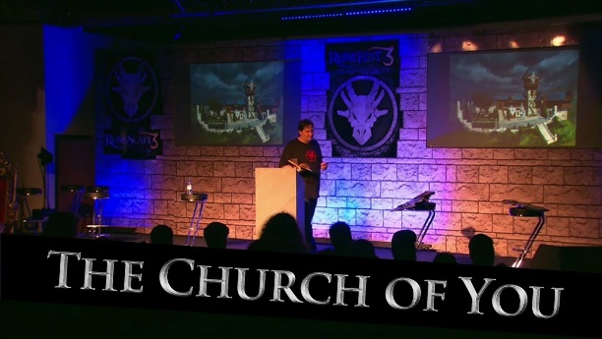
Welcome to the church of You! Haven’t heard of us? Well, not every church that follows our doctrine and practice wears this name, but you will know us when you see us. After all, we are the Church of You!
Our doctrine is distinctive because you are the most important part of this church, and whatever you believe is what we believe. Our practice is distinctive because – again – YOU decide what we do based on what pleases you and what you want to do!
The worship service is tailored especially for [do I need to say this] YOU! If you want the “traditional” worship service with songs that you learned as a child, you will get your wish. If you like the “contemporary” type of worship where it’s pretty much come-as-you-are and do-as-you please, then you will find this a most enjoyable visit.
The Church of You, as you have probably guessed, is becoming one of the most popular churches around. In fact, some churches are changing their names so they will be more closely associated with us. The old names only served to divide between fellow believers. And just think of the growth and unity we will have if every church focused on what you – the member wants! I cannot imagine any reason for fellow members to divide and start another church, when everything you want is right here.
Do you want to disregard certain Scriptures that seem to be narrow? You got it! Do you want to eliminate teachings that exclude family or close friends, or because you think it is not fair? We’ll do that for you!
If you don’t like feeling guilty for being a sinner or feeling this slightest bit uncomfortable, we’ll abide your wishes and tone things down. We can make worship a friendly get-together where we spend most of our time talking about how wonderful it is to have you worshipping with us. This is the Church of You. What you want is what you get!
If you think that the Scriptures prohibit the use of mechanical instruments in the worship service, we will abide by your wishes. But, if you have no problem with their use in the worship service, we’ll add whatever musical instruments you like, from a three-piece band to a full orchestra. If you want soloists and choirs, we can accommodate you there too. It doesn’t matter as long as you are happy with the way things are done and the message [that is, if you even want to hear one] makes you feel good. This IS the Church of You after all!
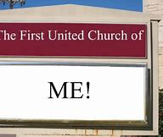
But is this the church you can find described in the bible? Is this the church for which Jesus died and purchased with His blood? Surely not! The church of You was not the one Jesus mentioned to Peter and the rest of the Apostles when He said, “And on this rock I will build MY church, and the gates of Hades shall not prevail against it.” [Matthew 16:18] Instead of calling it the church of You, it should accurately be called the church of Christ. After all it belongs to Him!
When you are looking for a church to join yourself to, are you looking for one that pleases you, or one that pleases God? Are you more concerned about what you feel or how God feels about the teaching, preaching, practice, and worship of the church you are considering? Will you join the church of your choice, or the one of God’s choice? If you are concerned about salvation, understand that you cannot enter into the kingdom of heaven unless you have done the will of the Father. ”Not every one who says to Me, “Lord, Lord,’ will enter into the kingdom of heaven except he who does the will of my Father in heaven.” [Matthew 7:21] – not YOUR will. The people in this context believed with all sincerity they were doing many wonderful things in the name of the Lord, but He condemned them for their lawlessness. The words that Jesus spoke – not your words – will judge you in the last day [John 12:48]
My plea is simple: Take a look at what you are doing, what you believe, and the church of which you are a part. What is the basis for what is done, taught, or accepted? The church of the New Testament is the church of Christ. It is not the church of You.


